Action Planning

A step-by-step guide to develop the FrEEIA action plan

Developing an FrEEIA Action Plan

This template provides a comprehensive template to develop an action plan as part of the FrEEIA readiness assessment tool process. The actions here have been identified during this process. Each section can be expanded with specific details relevant to the context of the health service and the priority population it serves.

# Introduction

The FrEEIA Readiness Assessment Tool process has identified a number of areas that could benefit from attention. A list of these areas can be found in [table XX in the cohort report]. The FrEEIA Readiness Assessment Tool process has also identified a number of actions that those completing the FrEEIA Readiness Assessment Tool feedback session have highlighted as important and feasible. This process to date is illustrated graphically below.

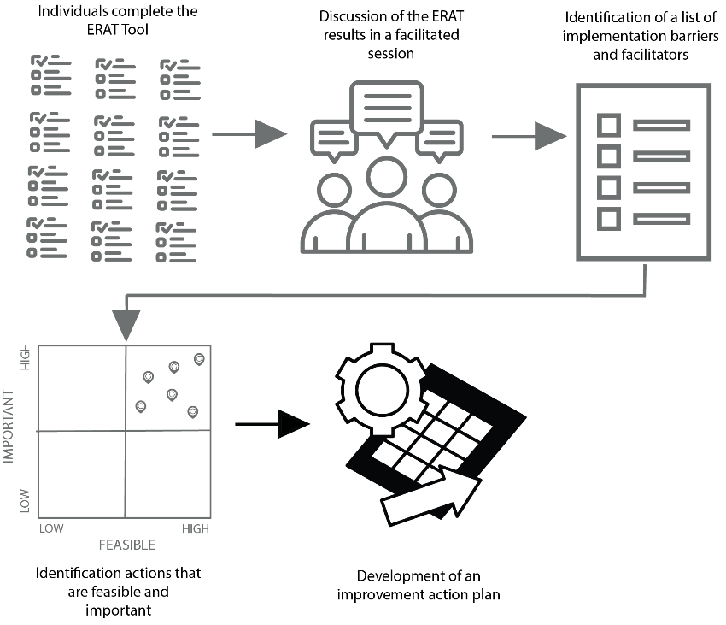

The next step is for those that are working on the action plan to bring all this material together, and develop a coherent plan for improvement. This involves the following steps:

|  |  |
| --- | --- |
|  | Reconciling the actions |

This step is only necessary if there were mutiple group facilitated discussions. Each session would have resulted in a small number of actions being identified. Combine these actions into one table, and remove any that are duplicates.

|  |  |
| --- | --- |
|  | Mapping actions against barriers and facilitators |

Take the table (from the cohort report) that shows the ordered list of barriers and facilitators. Map the actions against the relevent barrier(s) or facilitator(s).

At this stage in the process it is also important that you, as the team supporting the change, consider any other actions that may not have been identified as a result of the FrEEIA Readiness Assessment Tool process.

|  |  |
| --- | --- |
|  | Priortising actions |

For each action rate it on a scale of feasibility and likely impact. Plot all this information in the table below.

Based on the priortisation process select a small (3-5) number of actions to focus on in the improvement plan.

|  |  |  |  |  |  |  |  |  |  |  |  |
| --- | --- | --- | --- | --- | --- | --- | --- | --- | --- | --- | --- |
| **Barriers** | **Actions** | Feasibility to implement (1-Low – 5 High) | | | | | Impact on equitable outcomes (1-Low – 5-High) | | | | |
| Barrier 1 |  | 1 | 2 | 3 | 4 | 5 | 1 | 2 | 3 | 4 | 5 |
| Barrier 2 |  |  |  |  |  |  |  |  |  |  |  |
| .... |  |  |  |  |  |  |  |  |  |  |  |
| Facilitator 1 |  |  |  |  |  |  |  |  |  |  |  |
| Facilitator 2 |  |  |  |  |  |  |  |  |  |  |  |
| ..... |  |  |  |  |  |  |  |  |  |  |  |

|  |  |
| --- | --- |
|  | Defining the goals, activities, timing, and responsibilities |

Now that the action list has been refined down to the top priorities it is time to create the detailed improvement plan. This plan includes the goals, tasks, timeline, resources, and measures. The plan is stuctured to follow the typical stages of implementation – exploration, installation, initial implementation, full implementation.

In completing the plan work through each of the actions. It is likely that the activities for the later phases (e.g. initial implementation and full implementation) cannot be designed until the activities for the exploration and installation stages have been completed.

Complete this table for **EACH** action

|  |  |  |  |
| --- | --- | --- | --- |
| **Action 1**: [Describe it here] | | | |
|  | | | |
| **Goal**: [Define the goal this action is aimed at achieving. Define it as a SMART goal – specific, measurable, achievable, relevant, and time bounded] | | | |
|  | | | |
| **Exploration Stage**  At this stage the typical activites that need to be considered are:   * Leadership Champion: Obtain the necessary support from organisational leadership to progress the action * All members: The development of a communication plan to relevant stakeholder group [refer to the stakeholder assessment completed as a part of the implementation framework workbook] * All members: Activities that explore the resource availability, organisational readiness, and the capacity to implement. | | | |
| **Activities** | **Time Frame** | **Person(s) Responsible** | **Resources needed** |
| **Click here to enter text** |  |  |  |
| .... |  |  |  |
| [Add rows as needed] |  |  |  |
|  |  |  |  |
| **Installation Stage**  At this stage the typical activites that need to be considered are:   * Set up of any necessary infrastructure * Establish any necessary data capture systems, training, or recruitment * Start to try out the practices in a small scale, work out the details, learn and improve before expanding to other contexts | | | |
| **Activities** | **Time Frame** | **Person(s) Responsible** | **Resources needed** |
| **Click here to enter text** |  |  |  |
| .... |  |  |  |
| [Add rows as needed] |  |  |  |
|  |  |  |  |
| **Initial Implementation Stage**  At this stage the typical activites that need to be considered are:   * Systems are in place for coaching, data measurement, and reporting * Review of data that looks at the impact of the action * Communicating the impact of the activity to relevant stakeholders | | | |
| **Activities** | **Time Frame** | **Person(s) Responsible** | **Resources needed** |
| **Click here to enter text** |  |  |  |
| .... |  |  |  |
| [Add rows as needed] |  |  |  |
|  |  |  |  |
| **Full Implementation Stage**  At this stage the typical activites that need to be considered are:   * Monitoring systems are in place * Feedback processes are in place and functioning * Data relevant to the action is used by leadership to make decisions | | | |
| Activities | Time Frame | Person(s) Responsible | Resources needed |
| **Click here to enter text** |  |  |  |
| .... |  |  |  |
| [Add rows as needed] |  |  |  |

|  |  |
| --- | --- |
|  | Communications plan |

It is likely a number of the activities that have been identified relate to communication. Clear communication is critical for successful and sustainable change. Completing the following table helps keep a track of what needs to be communicated, to what groups/individuals, when, and how.

It will be helpful to refer to the communcation plan created as a part of the implementation framework workbook activities when completing the table below. Also consider the stakeholder mapping exercise that was completed. That identifies the different stakeholder groups, their concerns, and how they likely prefer to receive communication.

|  |  |  |  |
| --- | --- | --- | --- |
| **Action 1:** [Name the action here] | | | |
| **What needs to be communicated** | **Name of the group or individual** | **Timing** | **Method** |
| **Click here to enter text** |  |  |  |
| ........ |  |  |  |
| [Add rows as needed] |  |  |  |
|  |  |  |  |
| **Action 2:** [Name the action here] | | | |
| **What needs to be communicated** | **Name of the group or individual** | **Timing** | **Method** |
| **Click here to enter text** |  |  |  |
| ........ |  |  |  |
| [Add rows as needed] |  |  |  |

|  |  |
| --- | --- |
|  | Developing the measures |

In completing the FrEEIA framework exercise workbook exercise (Step 4), the relavant measures would have been identified for the intervention. This includes both the implementation related measures, and those that relate to the impact of the intervention. This data can be used to look at the impact of the actions and associated activities.

In addition to these measures, it is important to have measures that relate to the action plan. At a *minimum* these measures should include:

1. A list of any relevant measures that have been noted as activites in the action plan that relate to the actions.
2. A measure to track that the activities that have been agreed in the plan have occured.

The table below can be used to set up a way to record these measures.

|  |  |  |  |  |
| --- | --- | --- | --- | --- |
| **Action 1:** [Name the action here] | | | | |
| **Relevant measures** |  | **Activities** | **Expected completed date** | **Actual completed date** |
| List of measures to track the impact of the action |  | [Enter activity description] |  |  |
|  |  | ..... |  |  |
|  |  | [Add rows as needed] |  |  |

|  |  |  |  |  |
| --- | --- | --- | --- | --- |
| **Action 2:** [Name the action here] | | | | |
| **Relevant measures** |  | **Activities** | **Expected completed date** | **Actual completed date** |
| List of measures to track the impact of the action |  | [Enter activity description] |  |  |
|  |  | ..... |  |  |
|  |  | [Add rows as needed] |  |  |

In addition to this set of measures is it also possible to repeat the FrEEIA Readiness Assessment Tool and faciliated discussion after the intervention has been rolled out. From that report you can see if, where, and how there have been changes in how respondents are rating the ‘equity readiness’ across your organisation. This is a good overall measure of the impact of the readiness actions and associated activities you have been working on over the proceeding six months.