A Facilitator’s Guide

**Facilitating the Framework for Effective and Equitable Implementation in Aotearoa (FrEEIA) Readiness Assessment Tool Process**

Contents

**Introduction 3**

**Getting prepared 4**

Identifying the organisational sponsor/champion 4

Determining who to include in the FrEEIA readiness assessment process 4

Identifying people for the FrEEIA readiness assessment tool 4

Identifying people for the action plan 5

**Managing communication 5**

Introducing people to the FrEEIA readiness assessment process 5

Inviting people to complete the FrEEIA readiness assessment tool 5

Inviting people to be a part of the team that develops the action plan 6

**Introducing people to the FrEEIA readiness assessment tool and process 8**

**Distributing the FrEEIA readiness assessment tool 8**

**The FrEEIA readiness assessment tool facilitated workshop 9**

Preparing for the workshop 9

A suggested agenda 9

Team warm up exercise 9

Task 1: Group agreements 9

Task 2: Sphere of influence 10

Group discussion – Patterns in the results 11

**Developing the action plan 12**

# 

# 

# Introduction

This document provides guidance to those who are facilitating a process to implement an intervention to improve equity. There are six steps in this process, each with a number of outputs. This guide is designed to support the planning of each of these steps.

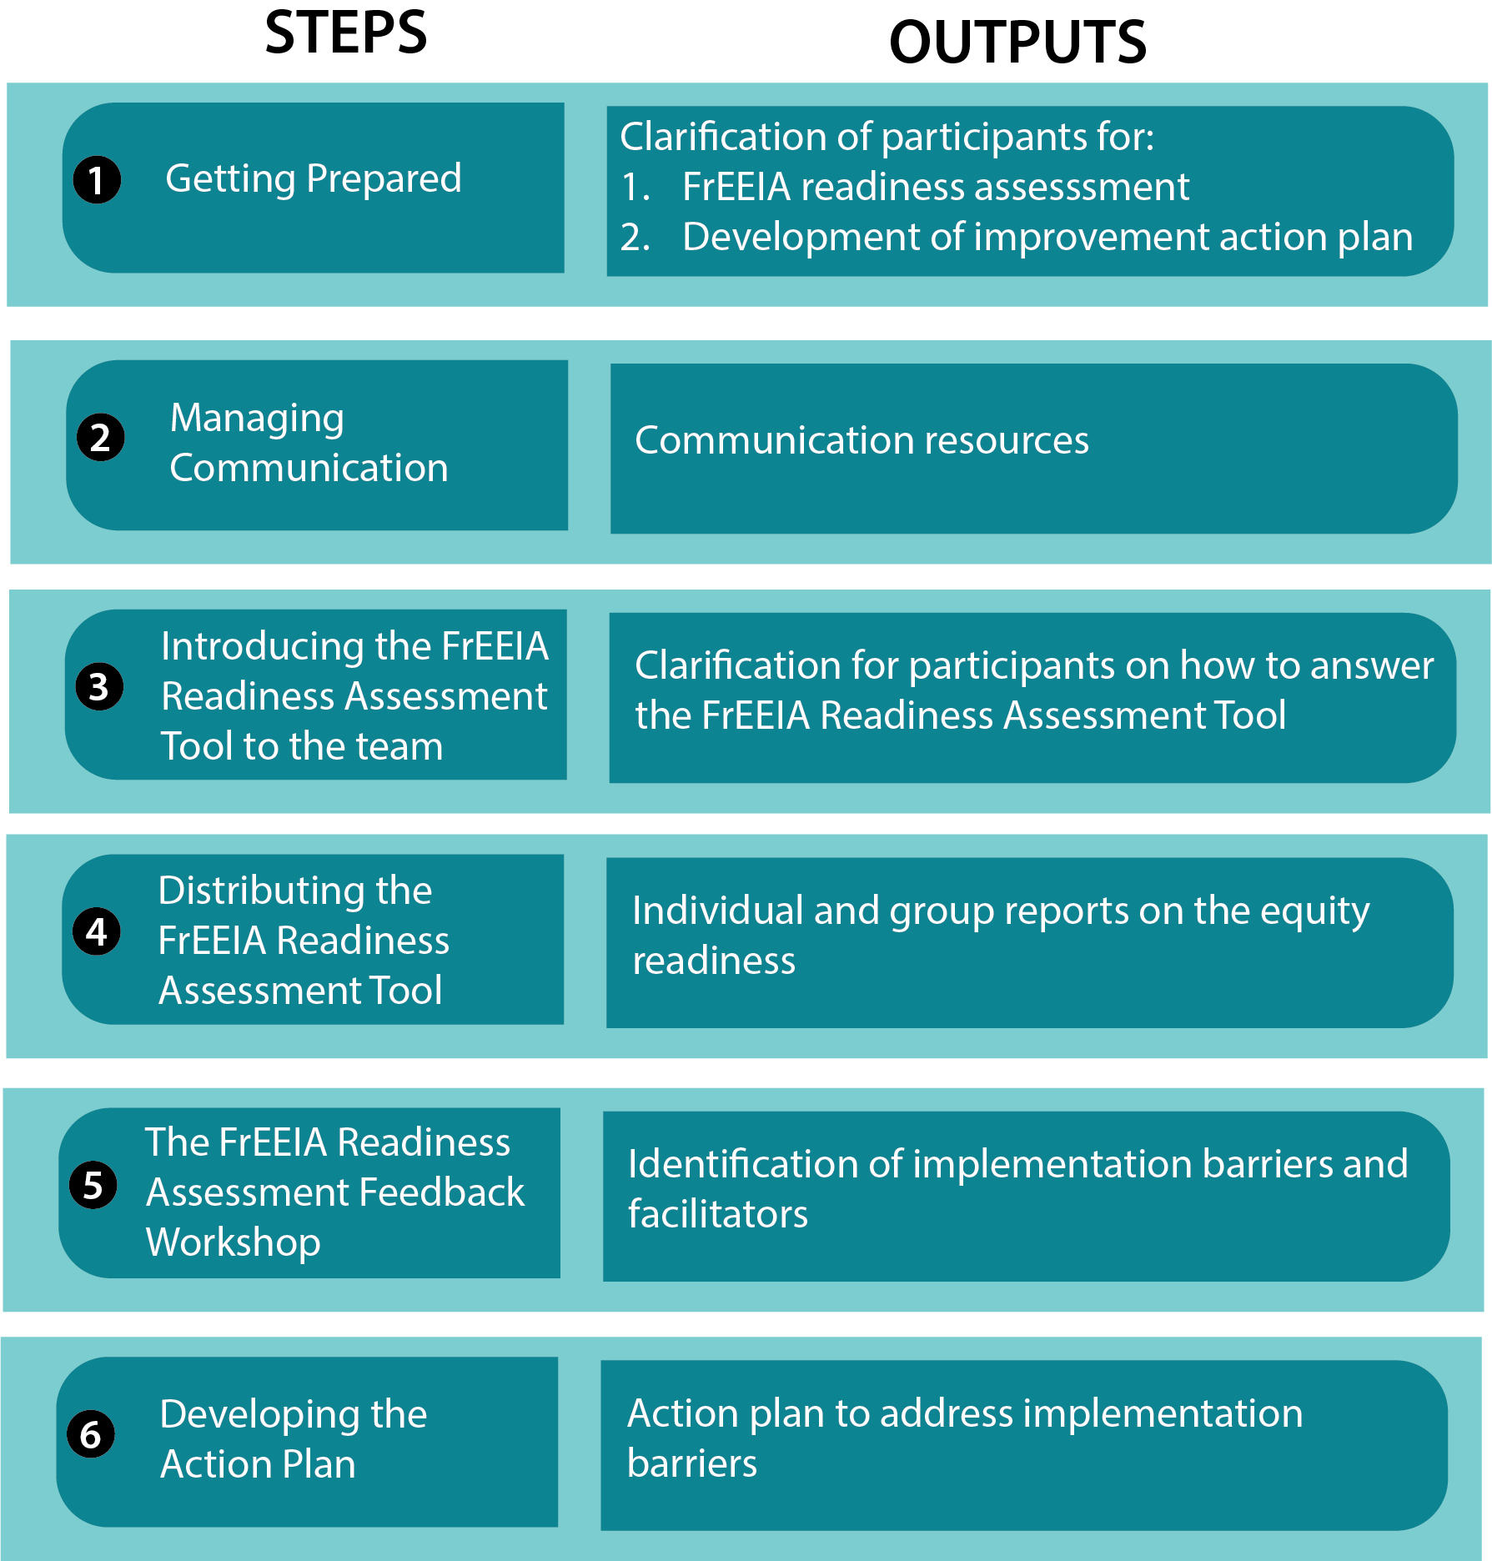

# 

# Getting prepared

Getting prepared to facilitate the FrEEIA readiness assessment process across your organisation has two steps:

1. Identifying an organisational sponsor/champion.

2. Determining who to include in the process.

### 

## Identifying the organisational sponsor/champion

Getting leadership support when implementing an intervention to improve equity is critical. There are two levels of leadership to consider here:

1. The organisational leadership champion. This is a person who typically sits at the senior leadership team level. Their role is to advocate for the intervention at the senior level, and communicate with senior leaders about progress and outcomes.
2. The team champion. This person typically will sit at the operational service level. They are likely a part of the team that is designing the intervention, and a part of the team responsible for the changes needed to address barriers identified to equitable implementation.

To support this process, the FrEEIA readiness assessment resources include a 2-page overview to be shared with both levels of leadership, so they are aware of what is involved, and what might be expected of the organisation in regards to supporting a FrEEIA readiness assessment.

## Determining who to include in the FrEEIA readiness assessment process

Central to the FrEEIA readiness assessment process is clarifying the people who will be included. The FrEEIA readiness assessment has two components:

1. Completing the FrEEIA readiness assessment tool.

2. Developing an action plan to address the implementation barriers identified.

In some organisations this will be the same people. However, it is likely that not all of those completing the FrEEIA readiness assessment tool will also be involved in developing the action plan.

### Identifying people for the FrEEIA readiness assessment tool

The FrEEIA readiness assessment process is both the completion of the online tool, and participating in a follow-up workshop (either face-to-face or online). It is recommended that the people selected to participate cover a range of perspectives and levels across the service(s) that you are looking to implement the intervention in. Each group should be 6-10 people in size. This is to ensure the follow-up workshop is manageable in size to facilitate an effective conversation. It may be that, in larger organisations, there are multiple groups that are completing the FrEEIA readiness assessment tool – all focused on the same intervention. This might also be the case in a context where the intervention crosses a number of services or organisations.

The following table is to be used to ensure there is good coverage of levels and perspectives in each of the FrEEIA readiness assessment groups that are established. At a minimum, there is one person at each level, and one of each role represented (e.g. 1 clinical front line, 1 mid-level manager, 1 mid-level administrative, 1 senior clinical)

|  |  |  |  |
| --- | --- | --- | --- |
|  |  |  |  |
|  | Front line | Mid-level | Senior |
| Clinical | [insert name] | [insert name] | [insert name] |
| Managerial | [insert name] | [insert name] | [insert name] |
| Administrative | [insert name] | [insert name] | [insert name] |

### Identifying people for the action plan

The people for developing the action plan ideally are those who have a good understanding of the system/service that the change will be embedded in. This group should also include those who have access to, or influence over, resources needed for the changes/improvements that have been identified. The following are the suggested roles to include in the group to develop and be accountable for the action plan.

1. The person who is responsible for managing the change, e.g. a service manager, clinical lead
2. A person who has influence over resource allocation decisions, e.g. the funder, service manager
3. Someone from the priority population that the service is focused on
4. Those with clinical leadership responsibilities.

# Managing communication

There are a range of things to consider when communicating with people about the FrEEIA readiness assessment process. This includes:

1. Introducing people to the FrEEIA readiness assessment process
2. Inviting people to complete the FrEEIA readiness assessment tool
3. Inviting people to contribute to developing the action plan as a result of the FrEEIA readiness assessment

## Introducing people to the FrEEIA readiness assessment process

We have developed a 2-page FrEEIA readiness assessment User Guide [[CLICK HERE to access the overview document]](https://www.impsciaotearoa.org.nz/_files/ugd/eaa2f6_9d9a12aeae36435b87b23b8b8e9c06b9.pdf). This provides an overview of the process, the research behind it, and how the outcomes will be used to support equitable implementation of a new intervention.

## Inviting people to complete the FrEEIA readiness assessment tool

The following is a draft email template that you can use to invite people to complete the FrEEIA readiness assessment tool:

|  |
| --- |
| Subject: Invitation to participate in an equity readiness self-assessment  Kia ora [Recipient’s Name],    I hope this message finds you well.    As we prepare to implement [insert name of the intervention] aimed at enhancing our service delivery, we are committed to ensuring that equity remains at the forefront of our efforts. To achieve this, we need your valuable insights to understand the current state of equity readiness within [insert name of organisation].    We invite you to participate in an evidence-based self-assessment that will help us identify the barriers and facilitators for equitable implementation of this new intervention. Your feedback is crucial in shaping our approach and ensuring that our services meet the diverse needs of our community.    The self-assessment will cover various aspects of how you perceive equity readiness within the part of the organisation you work in, including:  - Your views on the benefit and impact of the intervention  - Your views on the extent to which critical implementation factors have been considered to support the intervention  - The extent to which the broader organisation context is equity ready    Your participation is highly appreciated and will be instrumental in helping us create a more inclusive and effective service delivery model. The self-assessment is straightforward and should take approximately 10 minutes to complete.    We kindly ask that you complete the self-assessment by [Insert Deadline]. Your responses will be kept confidential and will be used solely for the purpose of improving our services.    You will receive a separate email that is generated by the FrEEIA readiness assessment tool website. This email will include a unique link for you to click to access the survey.    Thank you in advance for your time and valuable input. Together, we can make a significant impact on achieving equity within our services.    Ngā mihi,  [Your name] |

## Inviting people to be a part of the team that develops the action plan

The following is a draft email template that you can use to invite people to be a member of the team that designs the improvement action plan:

|  |
| --- |
| Subject: Invitation to Join Equity Readiness Improvement Action Team    Kia ora [Recipient’s Name],    I hope this message finds you well.    As we move forward with the implementation of our new intervention, we are committed to ensuring that equity is at the heart of our efforts. To effectively address the insights gathered from our recent self-assessment on equity readiness, we are forming a dedicated team to develop and implement an improvement action plan.  We are inviting you to be a member of this small, dynamic team responsible for translating the self-assessment data into actionable steps that will enhance our service delivery. Your expertise, perspective, and commitment to equity make you an ideal candidate for this important role.    As a member of the Improvement Action Team, you will:  - Analyse the data collected from the equity readiness self-assessment.  - Identify key barriers and facilitators to equitable implementation.  - Develop a comprehensive action plan to address identified issues.  - Implement and monitor the progress of the action plan.  - Collaborate with various stakeholders to ensure alignment and effectiveness.  Your participation will be crucial in ensuring that our organisation not only understands but also actively addresses the factors influencing equity within our services. This is an exciting opportunity to make a meaningful impact and contribute to the betterment of our community.    If you are interested in joining this team, please let us know by [Insert Response Deadline]. We will schedule an initial meeting shortly thereafter to outline our objectives and begin the planning process.    Thank you for considering this invitation. Your dedication to improving equity within our services is greatly appreciated, and we look forward to the possibility of working together on this important initiative.    Ngā mihi,  [Your Full Name] |

# 

# 

# Introducing people to the FrEEIA readiness assessment tool and process

It may be necessary to hold an introductory session so people are aware of the organisation’s intent to apply the FrEEIA readiness assessment process to support the equitable implementation of a new intervention. This is more likely in a large organisation. In a smaller organisation, where people know each other well, a formal introductory session is likely not necessary. Rather, the emails or noting at a team meeting will suffice. This can be supported with the 2-page FrEEIA readiness assessment tool overview document [[CLICK HERE to access the 2-page overview]](https://www.impsciaotearoa.org.nz/_files/ugd/eaa2f6_9d9a12aeae36435b87b23b8b8e9c06b9.pdf).

If there is to be a formal introduction session then the following provides a structure to follow:

|  |  |  |
| --- | --- | --- |
| Timing | Discussion point | Resources |
| 5 mins | Introductions, overview of the intervention, and the rationale for the FrEEIA readiness assessment process | 2-page overview of the FrEEIA readiness assessment process user guide and extra info on website |
| 5 mins | What to expect in the FrEEIA readiness assessment process |  |
| 5 mins | How the information will be used |  |
| 5 mins | Clarifying what people should consider as the ‘sphere of influence’ when responding to the FrEEIA readiness assessment tool | Have a map of the intervention pathway, and identify where different respondent groups sit on this pathway. See the activity below ‘Sphere of Influence’. |

# Distributing the FrEEIA readiness assessment tool

The following steps outline the process to follow to distribute the readiness assessment tool.

1. 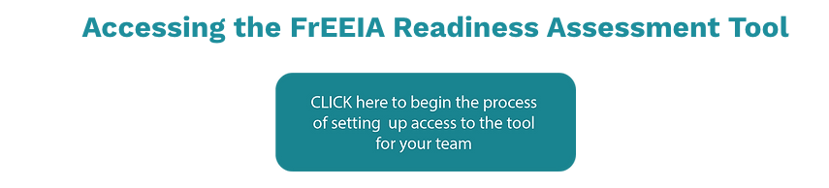A person that is facilitating the process firstly provides there contact details. This is achieved by going to Implementation Science in Aotearoa site at [THIS LINK.](https://impsciaotearoa.org.nz/freeia-readiness-tool#access-the-tool-1) Once there click on the button to begin setting up the access to the tool.
2. This will take you to the following screen. Please follow the instructions on the screen.

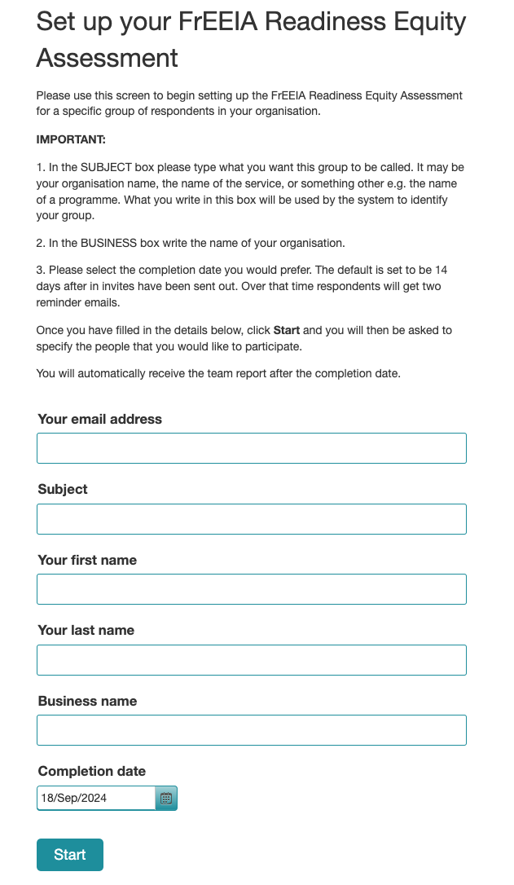

Write here the name you want this group to be identified as, e.g. service, organisation, etc

Write here the name of your organisation

This is set to 14 days by default. You can adjust it if you wish, but we recommentd it is kept at 14 days.

1. After you click the **start** button you will be sent to the following screen. You would have been automatically added as a respondent to the survey. To start adding others click the **add respondent** button.

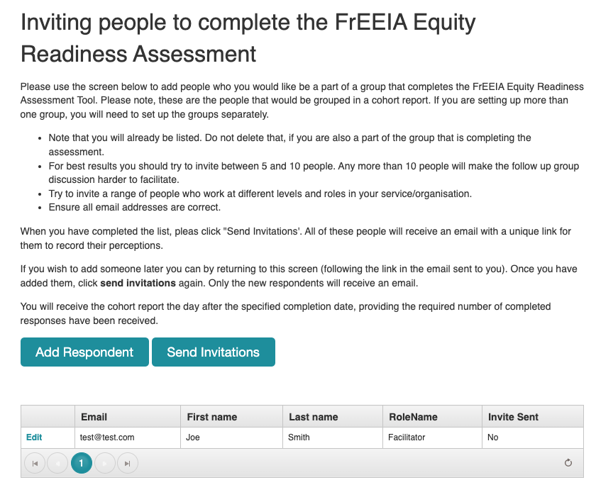

1. For each respondent you will add their email and name. In the role drop down select ‘team member’.

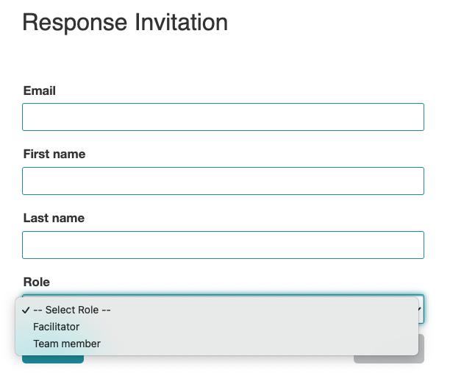

Select **team member** in the drop down

1. Once you had added all the details for those that you want to complete the FrEEIA RAT click the button labelled ‘send invitations’. People will then receive an automated email that invites them to complete the survey.

# The FrEEIA readiness assessment tool facilitated workshop

The following is a suggested guide for structuring the feedback workshop:

## 

## Preparing for the workshop

The following steps should be considered in preparing for the workshop:

1. Review the FrEEIA readiness assessment group report that was created from the individuals who completed the assessment tool. Note:

a. Where there are similarities and differences in scores.

b. Which areas are identified as needing attention.

1. Email people one week prior to the meeting with a reminder, a suggested agenda, and a copy of the FrEEIA readiness assessment cohort report [*The system will automatically email this to you*]*.*

### 

### A suggested agenda

Here is a suggested agenda, and timing for the workshop. Please adjust as you see fit.

|  |  |  |
| --- | --- | --- |
| Time | Item | Notes |
| 10 mins | Karakia and whakawhanaungatanga | Handout: Meeting agenda with group agreements on the back |
| 5 mins | Group agreements | See ‘Group agreements’ section below. |
| 10 mins | Clarifying the boundaries | See worksheet below on the ‘Sphere of influence’ exercise. |
| 20 mins | Group discussion 1 – Patterns in the results | See group discussion 1 notes below |
| 20 mins | Feasibility and impact matrix | See ‘Feasibility and impact’ exercise notes below |
| 15 mins | Considering actions | See ‘Identifying actions’ below. |
| 5 mins | Close and next steps |  |

## 

## Team warm up exercise

### Task 1: Group agreements

In discussing aspects about equity it is normal that there will be differing views on what equity is, why it matters, and how well the organisation/service is currently set up to improve equity. For this reason it is important that the group recognises that some ‘group agreements’ should be made.

The following is a suggested set of agreements. Please edit them as you see fit, and place them on the back side of the agenda you have prepared for the meeting.

Instructions:

1. Say something like: ‘Before we start we want to establish some group agreements. These are on the opposite side of your agenda. Can I have a volunteer to read them aloud?’

|  |
| --- |
| Group agreements |
| * Stay engaged. Speak from your own experience. Experience any discomfort that comes up as part of the learning process. Breathe. * If, when in groups discussing equity, you usually hold back, speak up. If, when in groups discussing equity, you tend to speak often, take a pause. * Expect and accept non-closure on long-term issues; the work is ongoing. * Listen for understanding. Honour concerns – ask for suggestions. No shaming, attacking or discounting. * Maintain confidentiality – if you later share about your experience in this workshop, refrain from using names. |

2. Share a personal take on why one of the group agreements is important to you.

3. Ask for a show of hands to indicate willingness to use these group agreements.

### Task 2: Sphere of influence

It is common in facilitating this session that people can struggle to understand where to focus their attention. There are many aspects of implementing an intervention to improve equity that may seem to sit outside of a person’s sense of control. For example, clinicians having little awareness of, if or where cultural leadership may sit in a large organisation. The risk if this is not addressed is the conversation can become too broad and unfocused.

To help provide focus to the conversation the following exercise is helpful.

1. Have a hand out prepared that maps the patient pathway that is relevant to the specific intervention you are implementing. Be clear on this pathway the relevant services and/or organisations that are contributing to the pathway in some way.
2. On that pathway get the people at the session to put a circle around the service they are a part of. Get them to label this circle as ‘my sphere of influence’.
3. Make it clear that it is this ‘sphere of influence’ that they are to think of when answering the FrEEIA readiness assessment questions, and discussing the factors that impact on barriers and facilitators for equitable implementation.
4. If people start to talk about factors outside their ‘sphere of influence’ remind them they have little to no ability to impact on areas outside of their ‘sphere of influence’. Rather, it is more helpful if they keep their discussion and observations contained within their own ‘sphere of influence’.

## 

## 

## 

## Group discussion – Patterns in the results

**STEP 1:** Take from the cohort report the *Assessment Summary* page that shows the level of readiness across the four domains. Ask the group to think about the domains that have the lowest level of readiness. It may also be helpful to have the more detailed charts for each of the domains.

### 

**Question for discussion:**

‘In thinking about our identified ‘sphere of influence’ discuss why we see these as important issues to address.’

Write these responses on a white board (or a shared screen if some are participating virtually)

**STEP 2:** Take from the cohort report the charts that show the different scores for each respondent to each question. Focus on areas where there is the greatest variance across respondents.

**Question for discussion:**

‘Here is the information from the cohort report that shows the areas where there is the greatest difference in views on how well different aspects of implementation equity have been addressed. What are your thoughts on why there are differences?’.

Write these responses on a white board (or a shared screen if some are participating virtually)

**STEP3:** Distribute sticky notes and pens to participants. Ask people to think about actions that can be done to improve the readiness for equitable implementation. Get the participants to write up to FOUR actions - each on a separate sticky note.

Once people have written down the actions, get them to place these notes on a 2x2 matrix that is illustrated below. Replicate this chart on a whiteboard on something similar. On the y-axis is low to high feasibility. On the x-axis is low to high impact on improving equity. Get the participants to take their sticky notes and place them on the chart, showing relative differences. This means that not all the sticky notes can be in the top left corner.

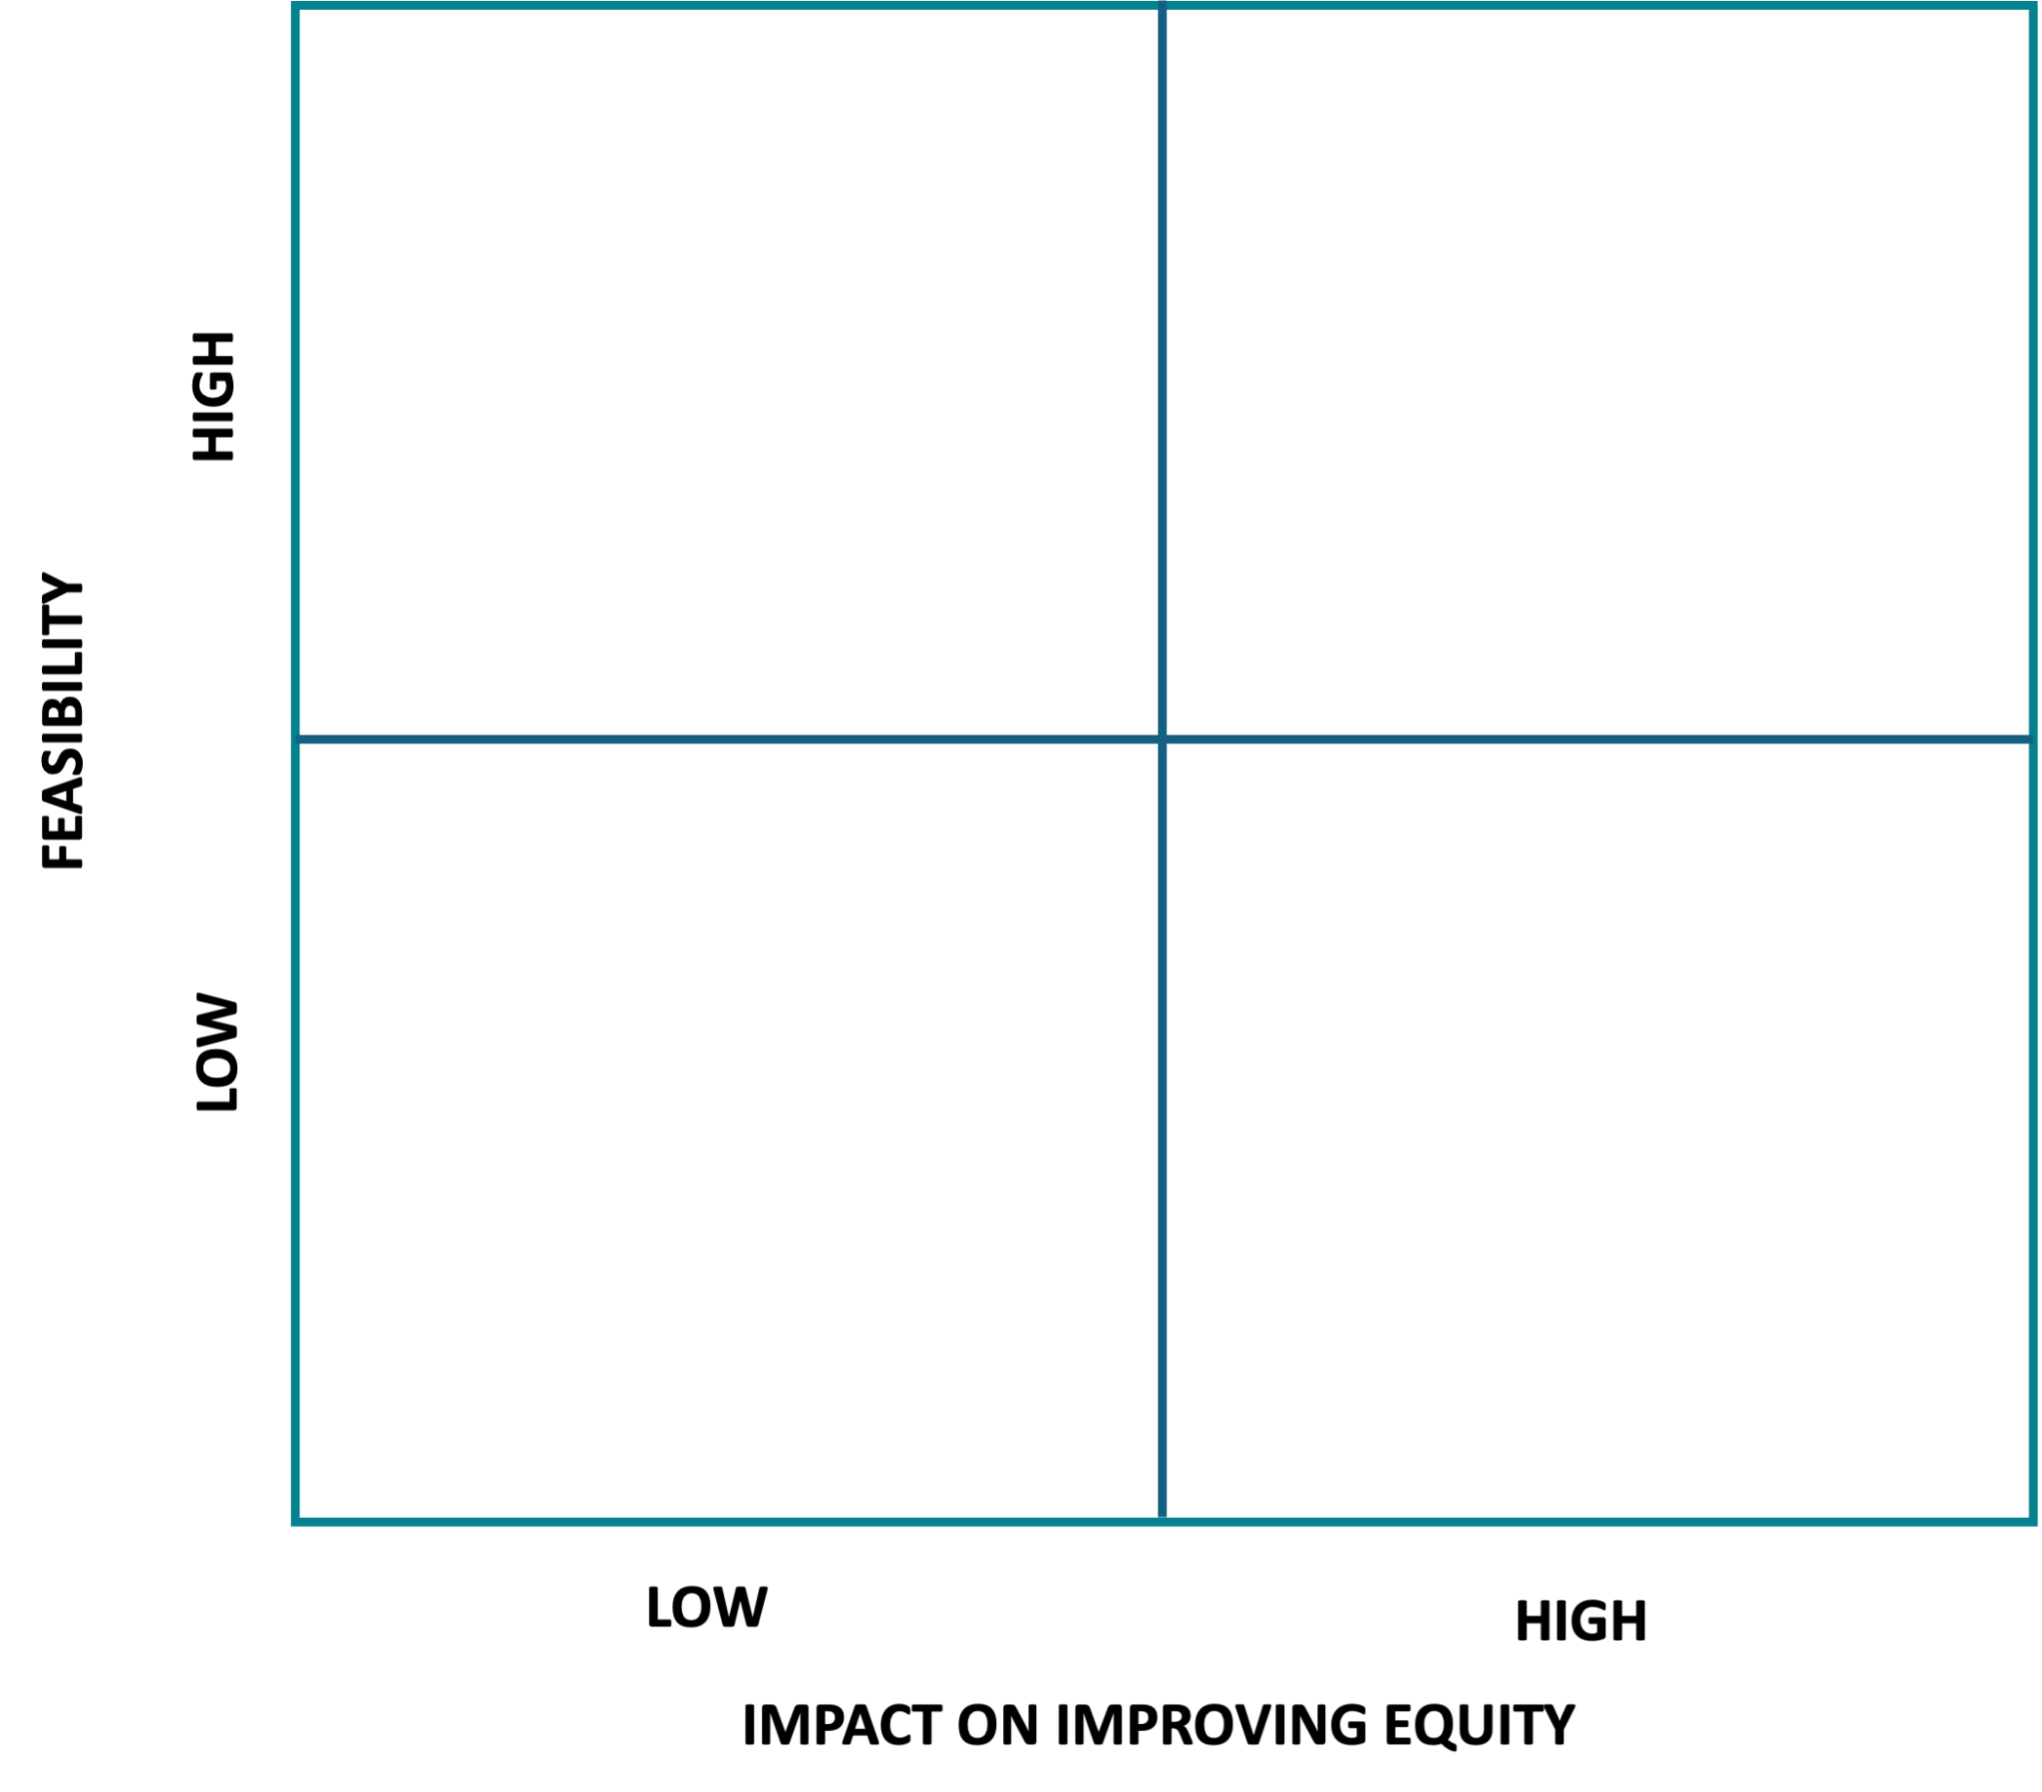

As a group decide on up to three areas that have been plotted on the top right corner of the feasibility/impact matrix. For each area discuss, at a high level, what can be actioned by the service(s) represented in this specific group.

For each action note:

a. What needs to occur

b. Why it is important

c. Any resource requirements

# Developing the action plan

See the document titled ‘FrEEIA Readiness Assessment Action Plan Template’. This can be accessed by clicking this [LINK](https://eaa2f674-014d-4265-b8b8-c80e9e4d63b3.usrfiles.com/ugd/eaa2f6_ab11e3c5e17e443e8cb32c57de7e03a8.docx).